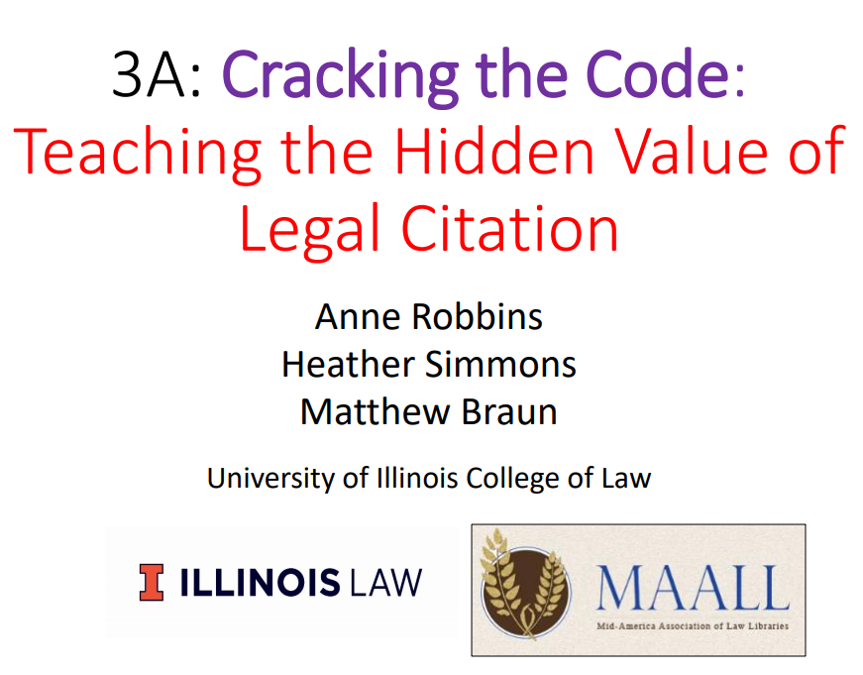

Introduction to the Purpose and Usefulness of citation Exercise.
You are writing a paper about the best techniques in legal research. In your research you have come across the same article multiple times in different places: ‘How Legal Research Rocks: Let Me Count the Ways’ by Sanjay Tenurestein. The article strongly supports your thesis so you would like to cite to it. However, you have encountered the article in six different places:
- The online institutional repository of the prestigious University that currently employs Tenurestein.
- Professor Tenurestein’s personal square space webpage.
- The blog of the Concerned Legal Researches of the Midwest, a blog that aggregates and publishes articles of interest to the legal research community.
- SSRN
- Legal Reference Services Quarterly (in print)
- The Monograph entitled: The Best Legal Research Articles of the Decade, Published by Oxford University Press.
You must decide where your citation should point. Please break into groups and discuss the best place to cite to and explain your answer.

Case citations:
Is it a Federal Court or a State Court?

- Which U.S. Court of Appeals covers Tennessee? __________________________________

- Which West Regional Reporter covers Tennessee? ________________________________

Federal Case Reporters |  |  | State Case Reporters (West’s National Reporter System)
U.S. Supreme Court |  |  | Region: Atlantic | States:
U.S. Supreme Court |  |  | Region: North Eastern | States:
U.S. Supreme Court |  |  | Region: North Western | States:
U.S. Court of Appeals (for the various circuits), precedential opinions |  |  | Region: Pacific | States:
U.S. Court of Appeals (for the various circuits), non-precedential opinions |  |  | Region: South Eastern | States:
U.S. District Courts |  |  | Region: South Western | States:
 |  |  | Region: Southern | States:

State Courts (see The Bluebook, T1.1, pages 248-302)
*= includes only the state’s highest appellate court
West Regional Reporter | State Highest and Intermediate Appellate Courts | Bluebook Citation Format
Atlantic Reporter | CT, DE, DC, ME, MD, NH, NJ, PA, RI, VT | A., A.2d, A.3d
North Eastern Reporter | IL, IN, MA, NY*, OH | N.E., N.E.2d, N.E.3d
North Western Reporter | IA, MI, MN, NE, ND, SD, WI | N.W., N.W.2d
Pacific Reporter | AK, AZ, CA*, CO, HI, ID, KS, MT, NV, NM, OK, OR, UT, WA, WY | P, P.2d, P.3d
South Eastern Reporter | GA, NC, SC, VA, WV | S.E., S.E.2d
South Western Reporter | AR, KY, MO, TN, TX | S.W., S.W.2d, S.W.3d
Southern Reporter | AL, FL, LA, MS | So., So. 2d, So. 3d
West’s California Reporter | CA | Cal. Rptr., Cal. Rptr. 2d, Cal. Rptr. 3d
West’s New York Supplement | NY | N.Y.S., N.Y.S. 2d

Illinois (see The Bluebook, T1.1, page 262)
Reporter | Court(s) | Dates | Bluebook Citation Format
North Eastern Reporter | IL Supreme + Appellate Courts | 1884 – present | N.E., N.E.2d, N.E.3d
Illinois Official Reports | IL Supreme + Appellate Courts | 2011 – present | IL
Illinois Reports | IL Supreme + Appellate Courts | 1819 – 2011 | Ill., Ill. 2d
West’s Illinois Decisions | IL Supreme + Appellate Courts | 1976 – present | Ill. Dec.
Illinois Court of Claims Reports | IL Circuit (Trial) Courts | 1889 – present | Ill. Ct. Cl.

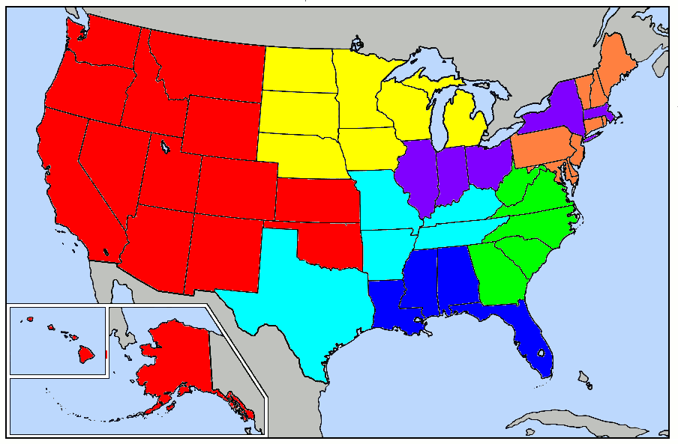

Statutes | Regulations
Chronological  SOURCE: ________________________  ________________  Volume Page  Containing Public Laws  PL ___ - ___ | Chronological  SOURCE: ________________________  ______________  Volume Page
Topic  SOURCE: ________________________  __________________ §  Title | Topic  SOURCE: ___________________________  _________________ §  Title

Statutes | Regulations
Chronological  Statutes at Large  ____ Stat. ____  Volume Page  Containing Public Laws  PL ___ - ___  <session of Congress> - <number of law> | Chronological  Federal Register  ____ Fed. Reg. ____  Volume Page
Topic  Legislative Code  United States Code  ___ U.S.C. § ____  Title Section | Topic  Administrative Code  Code of Federal Regulations  ____ C.F.R. § ____  Title Section or Part

Christopher G. Wren & Jill Robinson Wren, The Legal Research Manual: A Game Plan for Legal Research and Analysis, 18 (2d Ed. 1986).

https://www.amazon.com/Christopher-G-WrenResearch-Analysis/dp/B008VR91MW

