ITIL Continuous Service Improvement

 | Focus on value | Start where you are | Progress iteratively with feedback | Collaborate and promote visibility | Think and work holistically | Keep it simple and practical | Optimize and automate
What is the vision? | √ |  |  | √ | √
Where are we now? |  | √ |  | √
Where do we want to be? |  |  | √ |  | √ | √ | √
How do we get there? |  |  | √ | √ | √ | √
Take action | √ |  | √ | √
Did we get there? | √ |  |  | √ | √
How do we keep the momentum going? | √ |  |  | √ | √ |  | √

Agile
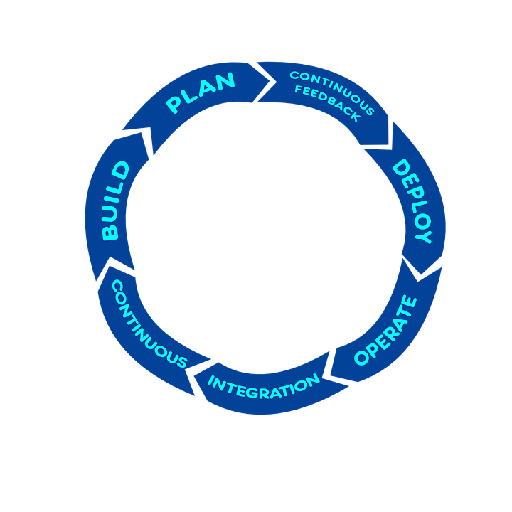

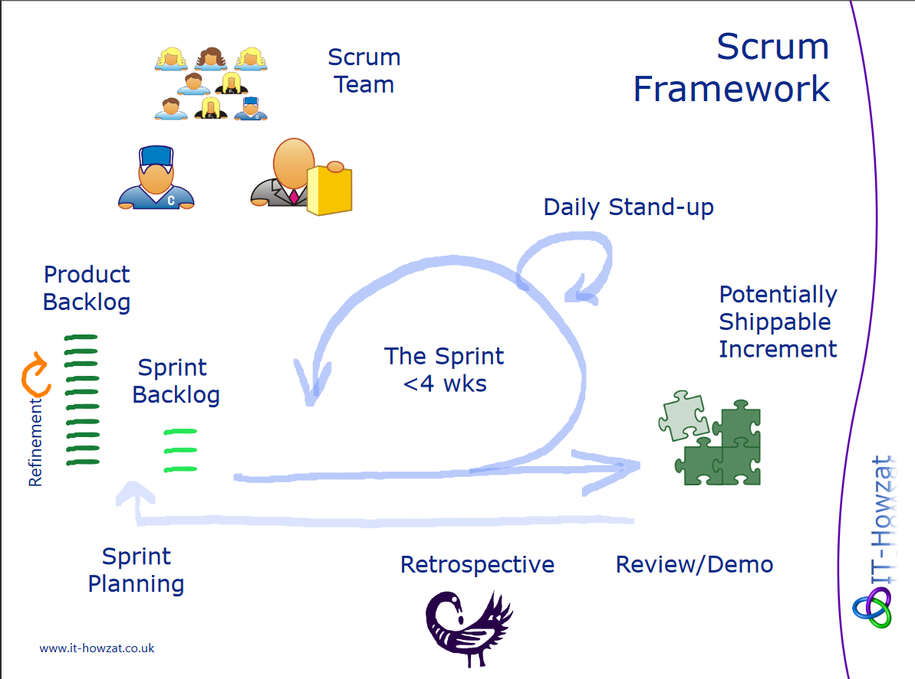
Scrum

